**TUGAS 5**

**TUGAS KELOMPOK**

**Wahyudin Zaelani (1127050167)**

**Windriyana (1211705166)**

**1. Buat state diagram dan activity diagram untuk studi kasus Restoran Pizza !**

State Diagram “Pemesanan”

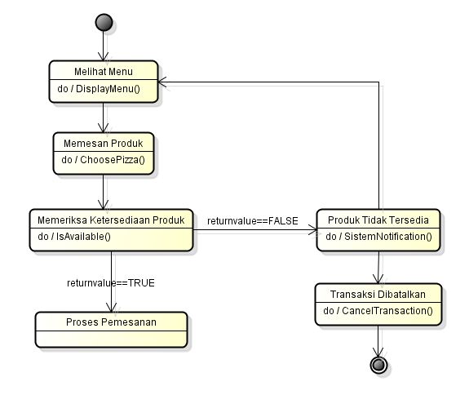

State Diagram “PizzaController” 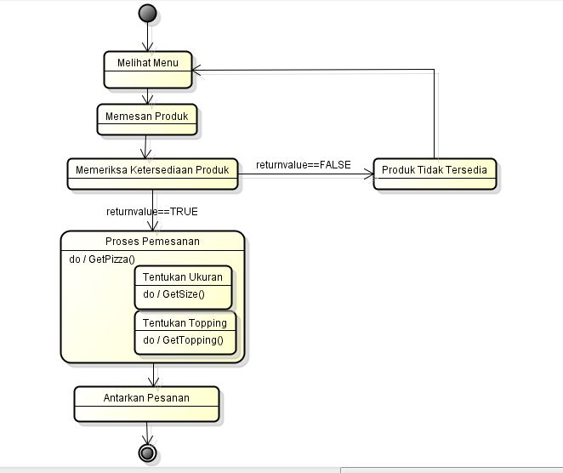State Diagram “Stok”  
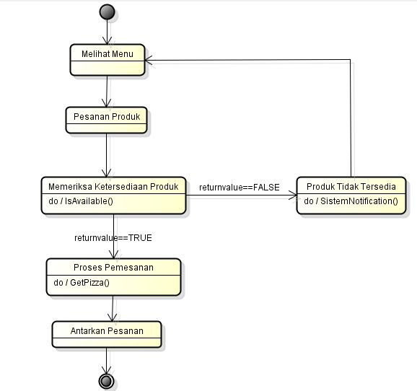

State Diagram “Transaksi”

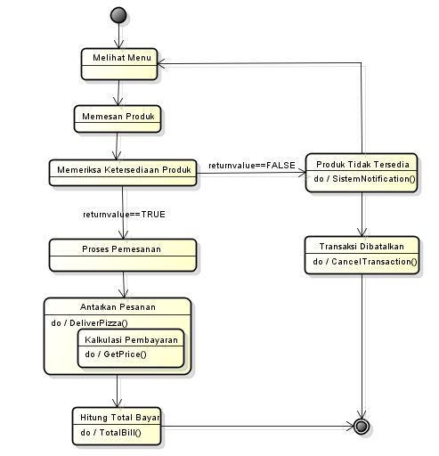

Activity Diagram “Pemesanan Pizza”

. . .